
Prenatal Food Box Program
Prenatal Food Box Program

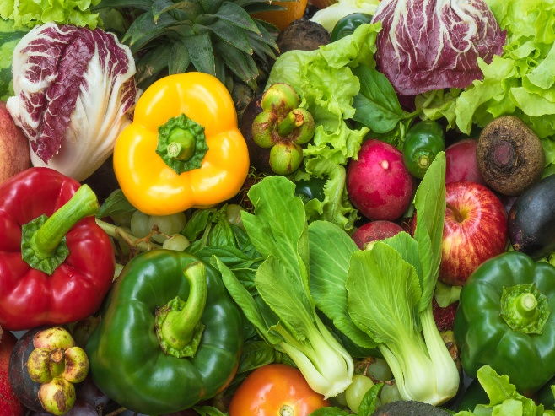
Are you pregnant or expecting?
Would you like or need a little extra assis-tance?
Having trouble access- ing valuable re- sources?

Location: Date/Time:
First Baptist Church 1st & 3rd Thursday Monthly
309 E Adams St 9 am – 11 am
Muncie, IN 47305 (Starting in August 2025)

Indiana Dept of Health (IDOH), in collaboration with, Gleaners Food Bank and the Delaware County Health Dept., will screen and identify eligible participants for the program to provide nutritious food boxes throughout the duration of the program. Along with the food, IDOH will provide recipe cards, prenatal vitamins, and resources for community services such as WIC and home visiting programs.
Possible services that might be included with the program:

Lead Testing
Lead testing for children from 9 months and above is available using point-of-care (POC) testing. The POC test results will be given within 5-10 minutes of testing and will be shared with the health dept.

Oral Health Screening

Screening patients for the purpose of identifying early signs of tooth decay and gum disease that will require the attention of a dentist in school aged children.

Questions?
If you have any questions about the Prenatal Food Box Program or any other questions about/for an OBGYN, diapers, or a place to ask parenting questions, feel free to reach out to Indiana Moms Helpline at 1-800-624- MOMS (6667)

Fast Facts
- Prenatal food box program can be
joined anytime during pregnancy.
- Extra services will be offered.
- The prenatal food box program will include one dry food box and one produce box.
- Insurance is not required, but if you have it, please have it ready to be given during registration.
- Will occur every two weeks.
- Must pre-register prior to your first event.

Registration location:
Web address:
https://redcap.isdh.in.gov/surveys/

Then enter this code:
4C79MH83W

Alternatively, if you have a device that has an app capable of reading QR codes, you may scan the QR code below, which will take you directly to the survey in a web browser.

