**FRANK FELSENSTEIN**

[**felsenstein@bsu.edu**](mailto:felsenstein@bsu.edu)

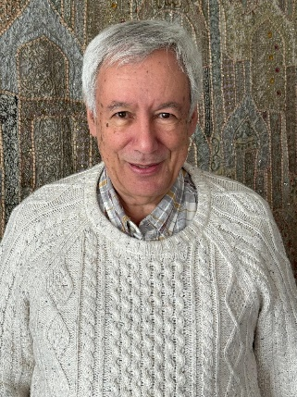

**EDUCATION**

1971 Ph.D. 1966 B.A. (Hons.) in English, University of Leeds: doctoral thesis on Tobias Smollett

**ACADEMIC EXPERIENCE 2002-2017** Reed D. Voran Honors Distinguished Professor of Humanities, **Ball State University**, Muncie, Indiana: Emeritus **2017-** ; **1998-2002** Professor of Humanities and Founding Director, Jay and Jeanie Schottenstein Honors Program, **Yeshiva College**, New York; also Visiting Professor of Book History, Caspersen School of Graduate Studies, **Drew University**, NJ; **1971-1998** Lecturer/ Senior Lecturer/ Reader in Eighteenth-Century Studies, **University of Leeds**, U.K.; **1989-1990** Visiting Professor, **Vanderbilt University**; **1968-1970** Assistant Lecturer in English**, Université de Genève**, Switzerland

**PUBLICATIONS: Books (selection)**

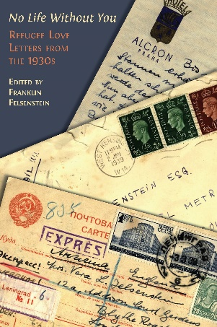

***“No Life Without You”: Refugee Love Letters from the 1930s***; Open Book Publishers, Cambridge, England, 2024, accessible via <https://www.openbookpublishers.com/books/10.11647/obp.0334> in both print and downloadable open access editions.

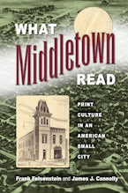

***What Middletown Read: Print Culture in an American Small City***; joint authorship with Dr. James J. Connolly; University of Massachusetts Press; xvi, 304 pp., 2015; hard cover and paperback editions

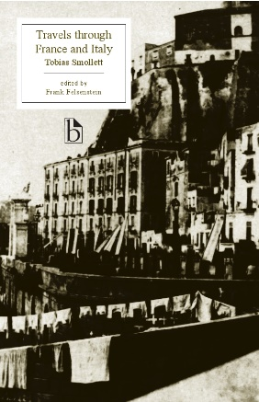

**Tobias Smollett, *Travels through France and Italy***, new and updated edition with extensive contextual appendices, for Broadview Press, Canada, 2011, 486 pp., to be available on-line 2024 (also Oxford University Press editions, 1979 and 1981)

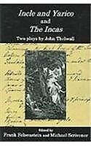

***Incle and Yarico* and *The Incas*: Two Plays by John Thelwall**, Edited by Frank Felsenstein and Michael Scrivener, Fairleigh Dickinson University Press, 2006, 168 pp.; hard cover

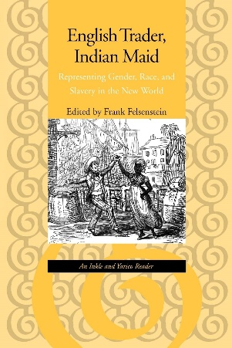

***English Trader, Indian Maid: Representing Gender, Race, and Slavery in the New World -- An Inkle and Yarico Reader***, Johns Hopkins University Press, 1999, 332 pp.: hard cover and paperback editions

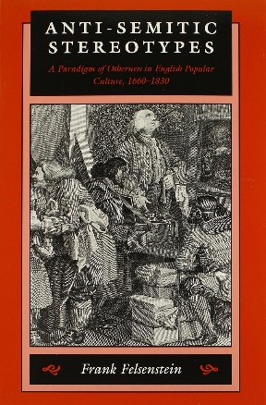

***Anti-Semitic Stereotypes: A Paradigm of Otherness in English Popular Culture, 1660-1830***, Johns Hopkins University Press, 1995, 376 pp.: hard cover; paperback (revised), spring 1999

**Contribution to Books and On-Line Presence (selection)**

“Was Smollett into Body-Snatching?: Deciphering a Hitherto Unpublished Letter”, in *Smollett at 300*, ed. Richard Jones, pp. 21-38 (Clemson and Liverpool University Presses, 2023)

“Truncated Memories: Berlin and Frankfurt in the Afterlives of Two Jewish Refugee Women,” *Times of Israel*, 27 September 2017, at <https://blogs.timesofisrael.com/truncated-memories-berlin-and-frankfurt-in-the-afterlives-of-two-jewish-refugee-women>

*Print Culture Histories Beyond the Metropolis*; jointly edited volume with four others (University of Toronto Press, 2016)

‘“If you tickle us, do we not laugh?”: Stereotypes of Jews in English Graphic Humor’: Ch. 3 [pp. 49-75], in *No Laughing Matter: Visual Humor in Ideas of Race, Nationality and Ethnicity*, ed. Angela Rosenthal et al, (UP of New England, 2015)

Joint authorship with three others, “Colman’s *Inkle and Yarico:* Four Critical Perspectives,” *The Oxford Handbook of the Georgian Theatre*, *1737-1832*, ed. Julia Swindells and David Taylor (Oxford University Press, 2014), 688-705

*What Middletown Read* – Collaborative project based on nineteenth-century ledgers in Muncie Public Library; launched March 2011; see [www.bsu.edu/libraries/wmr](http://www.bsu.edu/libraries/wmr).In 2015, What Middletown Read was selected as one of the fifty prime projects (out of 63,000) funded by the National Endowment for the Humanities; see <http://50.neh.gov/projects>

**Recent Presentations (representative selection)**

“An Ekphrastic Interlude: From Mainland Liberty to Island Enslavement in the Story of Inkle and Yarico” (Columbia University Seminar on Abolitionism and the Arts, May 2023 (<https://abolitionism.universityseminars.columbia.edu/home>)

“From Gutenberg to Google: Teaching Book History from the Bracken Library”: Annual Kirkham Lecture: Friends of the Bracken Library, Ball State University, Muncie, Indiana, May 2023. A curated exhibition of artifacts accompanied the talk.

“No Life Without You”: Annual Yom Hashoah (Holocaust Memorial) Lecture, Sinai Synagogue, Chicago, April 2023

“No Peaceful Burial Place: Encountering Body Snatching and the Early Teaching of Practical Anatomy from a Letter of Tobias Smollett to Dr. William Hunter”: International Museum of Surgical Science, Chicago, March 2023

“Jews in English Caricature” and “World War 2, Jews, and Cartoons,” adult education, Sinai Synagogue, Chicago, March 2023

**RESEARCH AND WORK IN PROGRESS**

*Rowlandson’s Jews: Visual and Textual Representations of Jews and Judaism in English Popular Culture at the Turn of the Nineteenth Century*