RQI Description
The RQI BLS Program (Resuscitation Quality Improvement – Basic Life Support) is a blended learning and performance improvement program developed by the American Heart Association (AHA) in collaboration with Laerdal Medical. It is designed to help healthcare providers maintain and improve their CPR and basic life support (BLS) skills continuously, rather than through traditional certification every two years.
Key Features:
- Quarterly, short training sessions (approx. 10 minutes) using feedback-enabled manikins
- Focus on high-quality CPR performance and skill retention
- Self-directed, allowing learners to practice at their convenience
- Includes real-time audio-visual feedback to ensure correct technique
- Replaces traditional classroom BLS training and certification
Goal:
To improve survival outcomes from cardiac arrest by ensuring healthcare professionals are always ready to perform effective CPR.
RQI Process
You will receive an email from RQI 1Stop Learning Platform (donotreply@rqi1stop.com) with the subject “New assignment available.” You may use the link in the email or go to bsu.rqi1stop.com to begin your training.
Initial RQI training consists of two sessions: cognitive training and skills testing.
Students will complete the cognitive portion of the training online, at their own pace. This will provide the knowledge necessary to perform CPR and basic life support. Once completed, students will utilize the RQI simulation cart to complete hands-on skills testing, which provides real-time feedback. Once you have successfully completed the skills testing, you will be awarded your initial BLS certification.
After the successful completion of the initial training sessions, students will complete quarterly knowledge and skill check-ups to maintain certification.

Online Cognitive Training
Close all browsers. Open an incognito window.
Log on to bsu.rqi1stop.com utilizing your BSU credentials. The system will guide you through the training. This training must be completed successfully before you can complete the skills testing.
Once signed in, you should see two assignments: RQI 2025 Student Healthcare Provider Prep Assignment and RQI 2025 Student Healthcare Provider. The Prep Assignment includes both the cognitive and skills portions of your training. Activate this program and follow the guided prompts to complete your training.
Assignments should be completed in the following order:
- Welcome to RQI
- Questionnaires
- eLearning: Cognitive Assessment
- Manikin Activity: Baseline Skills Check (to be completed at RQI station)
- Manikin Activity: Core Skills (to be completed at RQI station)
RQI 2025 Student Healthcare Provider will include your quarterly trainings and can be activated at any time but will not be utilized in your initial training.
Skills Testing
Follow the steps below to reserve a study room in the Health Library, located in HB101 in the Health Professions building. You may also check with library staff if a walk-in time is available.
Open laptop screen. Select Start Skills Training icon on the desktop. Do not select BSU Community.
Follow prompts to log in to RQI. The system will guide you through the skills testing with real-time feedback. You will complete:
- Adult/child compressions (1 minute)
- Adult/child ventilation (1 minute)
- Infant compressions (1 minute)
- Infant ventilation (1 minute)
During your initial training, you will complete this process twice. Once without feedback to gather baseline information and once with feedback for skills testing.

Utilizing the Simulation Station
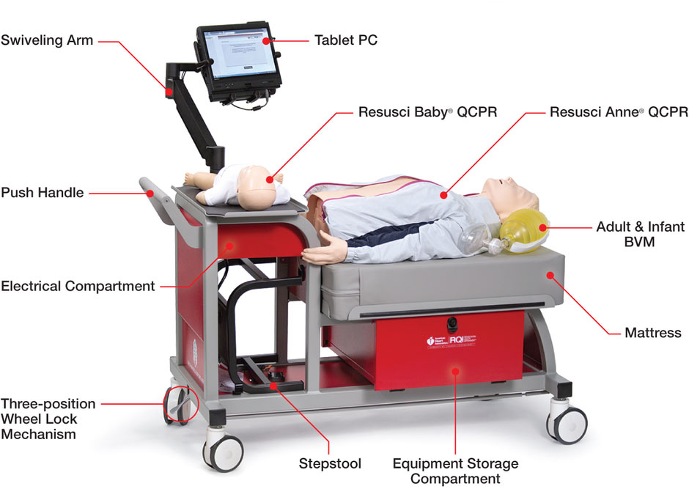
Make sure the cart is in a locked position before beginning, with the wheel lock mechanism pressed all the way down.
The laptop arm is adjustable. Adjust it so you can see the feedback while completing the skills testing.
There is a stool connected to the cart that can be used to get a better angle for chest compressions. It is strongly recommended for those 5’5” and under.
The bag valve masks for ventilation are located in the equipment storage compartment on the side of the cart. Please return them here when you are finished.
Once logged in, navigate to the RQI 2025 Student Healthcare Provider Prep Assignment and select resume. You will first complete Manikin Activity: Baseline Skills Check. This will be done without feedback. Once complete, you can move on to Manikin Activity: Core Skills. This is your skills testing.
The system will provide feedback. You must complete the skills with 70% or greater accuracy. If you continue to fail the skills testing, take a break and review the guidance videos. You can come back at another time to redo any skills you do not pass.
Please wear gloves while utilizing the simulation station. When you are done, please wipe down both manikins with the provided alcohol-based cleaning wipes. Do not use bleach-based cleaners.
Return the bag valve masks to the equipment storage compartment, close the laptop screen, and let the library staff know you are finished.
How to Reserve a Study Room
- Go to https://lib.bsu.edu/openroom2/
- Select Reserve a Study Room (cookies required)
- Login with your BSU credentials
- Select Reserve a Room
- Select your preferred date and time
- Under Pick Room Group, select Health Library
- Click Check Availability
- If available, select Choose Room. If unavailable, please go back and select a different date and time.
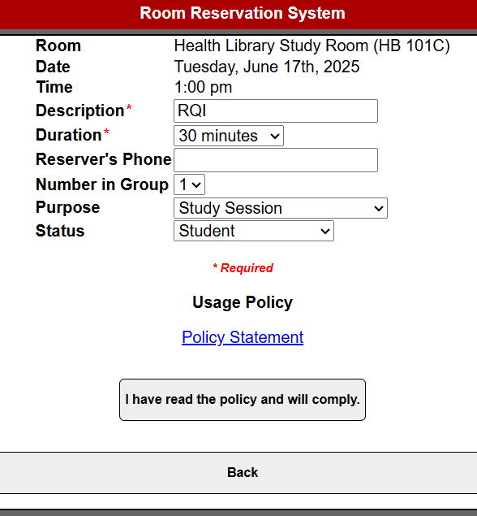
- On the next page, under Description, enter RQI
- Duration: 60 minutes. Most can complete this process in less than 60 minutes or less. However, if you are concerned about time, please reserve for longer.
- Review the Usage Policy.
- Select I have read the policy and will comply.

FAQs
What am I required to do in the RQI Program?
The RQI Program includes the same cognitive and skill modules as a conventional American Heart Association training program. The difference is that the RQI Program delivers the full training content over a two-year period rather than in one or two days every two years. Both the cognitive and skills modules will be assigned to you, with deadlines for completion of the modules to keep your credentials current. Quarterly, you will complete cognitive online learning modules (10-15 minutes per module) and 4 core skills (adult and infant compressions and ventilations) to achieve mastery.
How does the RQI Simulation Station work?
Once you are at a station, turn on the computer and log into the system following the instructions above. Find the RQI assigned curriculum in your To Do list and select it. That will launch the RQI platform where you will complete your skills assessment. You will be guided all the way through this process.
Where will the simulation stations be located?
Simulation stations will be located in the Health Professions building in the Health Library and on the third floor (*Note: 3rd floor station will not be available until Fall 2025). You do not need to use the same Simulation Station each time. The Simulation Station on the third floor is available during building operation hours, while the station located in the Health Library is available during library hours and should be reserved following the steps to reserve a study room.
What kind of skills will be practiced/reviewed at the Simulation Station?
Each quarter you will have the same 4 core skills to complete.
- Adult/Child compressions (to be completed on the adult manikin) – 1 minute
- Adult/Child ventilations (to be completed on the adult manikin) – 1 minute
- Infant compressions – 1 minute
- Infant ventilations – 1 minute
During your first quarter, you will perform each skill twice to record a baseline.
Do I have to complete all the skills at one time?
No, you can log out and log in to the assignment with the required activities and complete them at your convenience, but each individual activity needs to be completed in one sitting.
Can I complete the RQI quarterly activities in advance?
No, new assignments are only made on a quarterly basis and are unavailable until the first day of the quarter.
Once I have completed the online and skills activities, can I get back in to review and refresh at any time?
Absolutely, you can return to either the online (cognitive) or the skills modules at any time to retain your knowledge. Learners just need to go back in to their completed activities section to relaunch a completed module.
What if I need help with the simulation station skills?
When at the simulation skills stations, each assignment has helpful videos you can choose to watch. Also, the associated AHA book is available electronically within the RQI program. You will receive audio and visual feedback to help you be successful.
What if I don’t pass the skills assessment when using the Simulation Station?
If at first you don’t succeed try, try again! There is no limit to the number of times you can access the content. However, after three unsuccessful attempts you will be alerted to take a break and try again later (remember you have been doing chest compressions for a good amount of time, and you need to rest). At no time will a student be locked out and unable to continue to make attempts.
What if I have a problem completing a skill assessment at the Simulation Station?
Feedback from the RQI Program is designed to increase the likelihood that you will be able to successfully complete the assigned skill module. If you feel there is something wrong with any simulation station equipment, please contact Theresa Mince at theresa.mince@bsu.edu. DO NOT under any circumstance attempt to “fix” a simulation manikin. While machines do break, 90% of the issues with skills completion are that the skill is not being done adequately.
What is the cleaning protocol?
Please wear gloves while completing your skills testing. Use an alcohol-based cleaning wipe provided at each simulation station when you are finished. Please do not use bleach-based solutions.
I work at another organization that requires BLS certification, how do I get my e-card for needs outside of my organization?
Within the RQI program, we have eCredentials (your e-card). However, we understand that sometimes you need a traditional 2-year card for other reasons (i.e., other employers, school requirements, etc.). Upon completion of your quarterly activity, you have the option to “View eCard” and it has both your eCredential for RQI and a 2-year traditional e-card you can print. It also has a QR code you can scan and store in your phone for easy access. Remember, our expectation is that students will remain competent and compliant within RQI, regardless of the expiration date on a 2-year traditional e-card.

