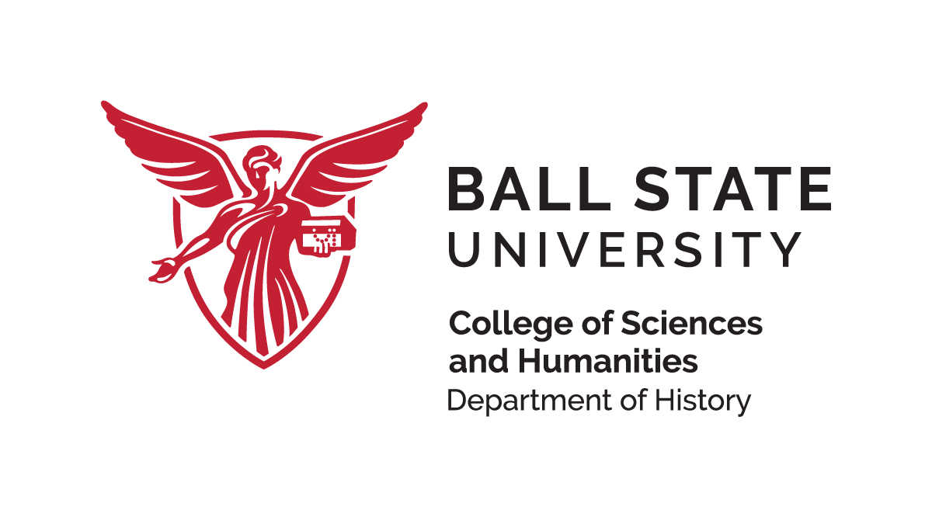
Stephen J. Sr. & Beatrice Brademas Memorial Scholarship

Although much of the contemporary world has been shaped by the Industrial Revolution and what has occurred since then, many present-day cultural practices continue to be influenced by traditions established at an earlier date. This scholarship is intended to encourage the study of classical cultures that have shaped our history. If possible, preference will be given to students pursuing an academic interest in pre-industrial classical cultures’ impact on the contemporary globalized world.
Those eligible are entering freshman students, transfer students or current students who plan to major in, or are majoring in history or social studies education.
- A GPA of 3.0 or higher is required.
- The scholarship is renewable up to a total of four years eligibility, as long as the student continues to meet the stated criteria.
Application requirements
Please submit a letter of application, explaining how pre-industrial cultures continue to impact us today. Examples of topics include the traditions of the Middle East, the Greco-Roman world, Classical China and the impact Indigenous American and West African traditions in the western hemisphere.
Also include a résumé, indicating GPA and two current references.
Due Date: February 28, 2023
Submit Application Electronically to jsims2@bsu.edu.

